This fanfic's title, The Storm, is not a weather reference. It is the day of reckoning anticipated in Qanon conspiracy theories, when the military and patriot citizens will rise up in deadly wrath against the corrupt Washington and Hollywood elites.
This story takes an unflinching look at just how ugly the unthinking hatred and contempt underlying our national politics has become. It describes a near future we still have the choice to avoid. But, as a character declares early on, "If we continue down this road, I guarantee we won't like what we find at the end of it."
An ongoing theme of The Race Bannon Adventures has been Team Quest's struggle to come to terms with a future very different from what they would've envisioned in the era of Classic Jonny Quest. The Storm pushes that struggle to a new level.
The account of a Navy SEAL team going rogue during the 2019 Syria pullout is fictional. The broader narrative of the then White House's abandonment of our Kurdish allies to appease Turkey is unfortunately true. This includes the murder of Hevrin Khalef and descriptions of Ahrar al-Sharqiya.
Writing near future fiction is challenging as real world events catch up very quickly. When I started The Storm, a new Russian invasion of Ukraine was still a speculative threat. While I considered moving the Russian invasion scenario to a totally fictional battlefront, Ukraine has played such a central role in US Presidential politics and in the new cold war between oligarchy and democracy, that I decided to keep it. Time will tell how well the narrative I've laid out holds up or doesn't.
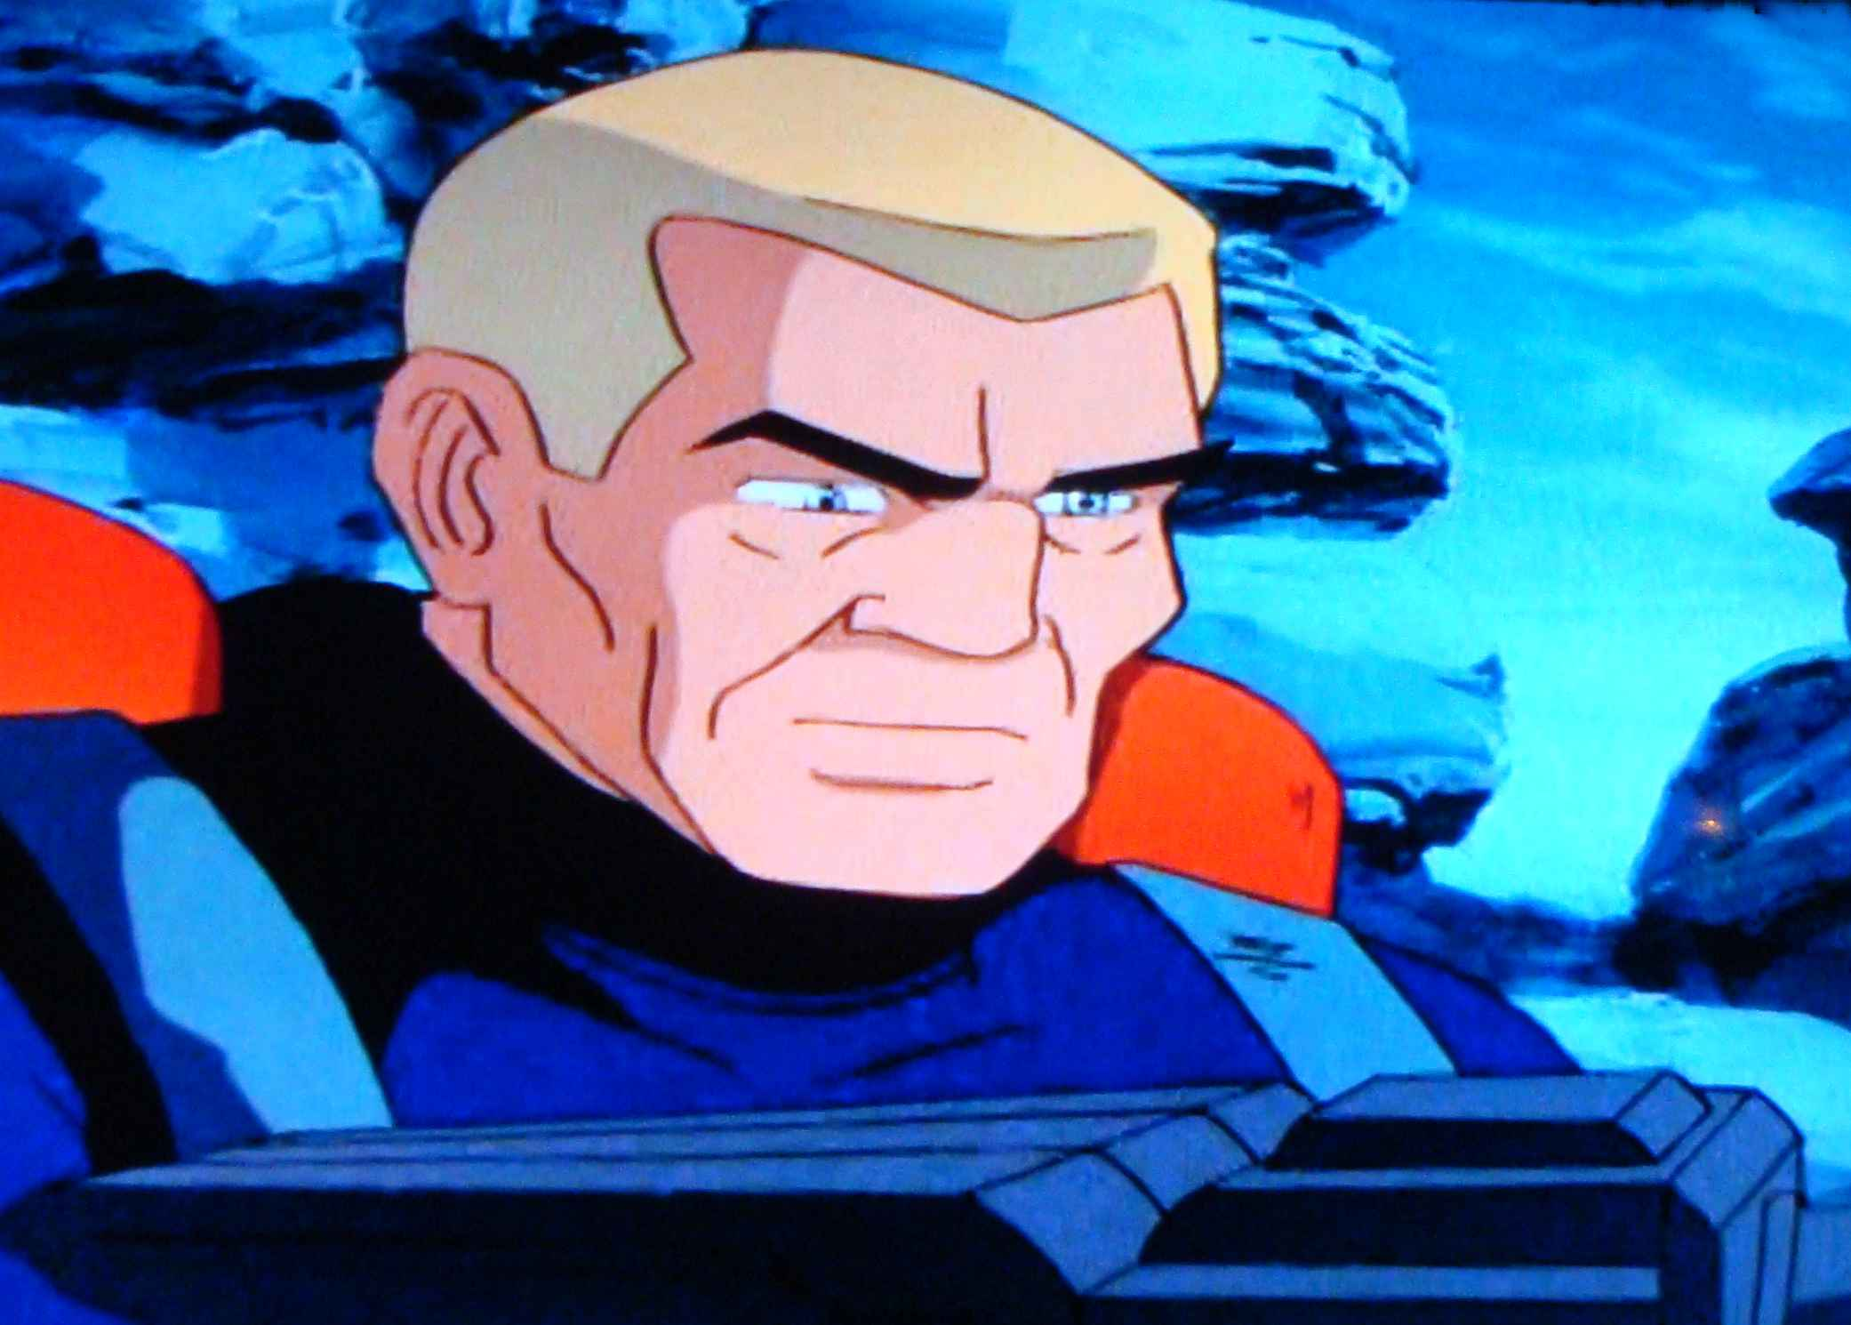
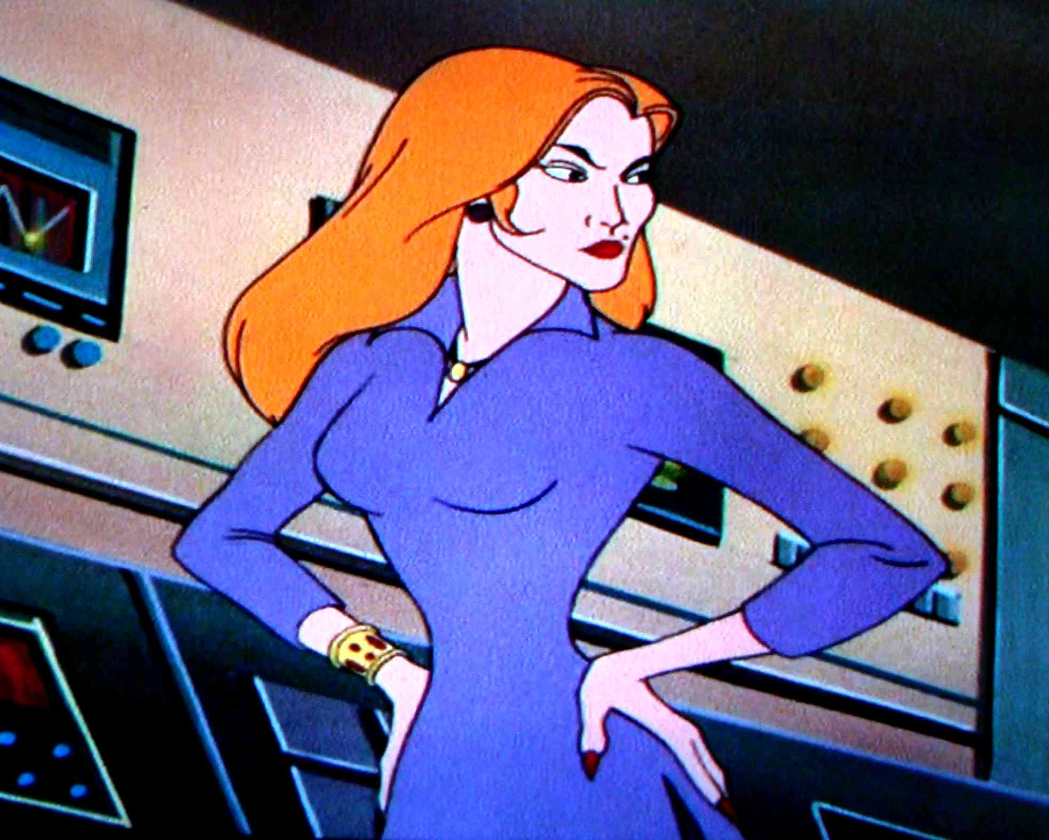
The Storm features the return of Deprava from the Eighties Adventures episode Temple of Gloom. This character is also identified as Deprave or Dibrana by various JQ reference sites. It also brings back Von Romme Industries' security chief, Mr. Corey, from the Real Adventures episode Nuclear Netherworld. The location of Crystal Cove is a nod to Team Quest's cameos in Scooby Doo, Mystery Incorporated.
The unique story locations of Bombay Beach and Salvation Mountain are showcased in multiple YouTube videos. I would encourage interested readers to check these out to enhance your reading experience. The Zumwalt-class destroyer Michael Monsoor can also be viewed on YouTube.
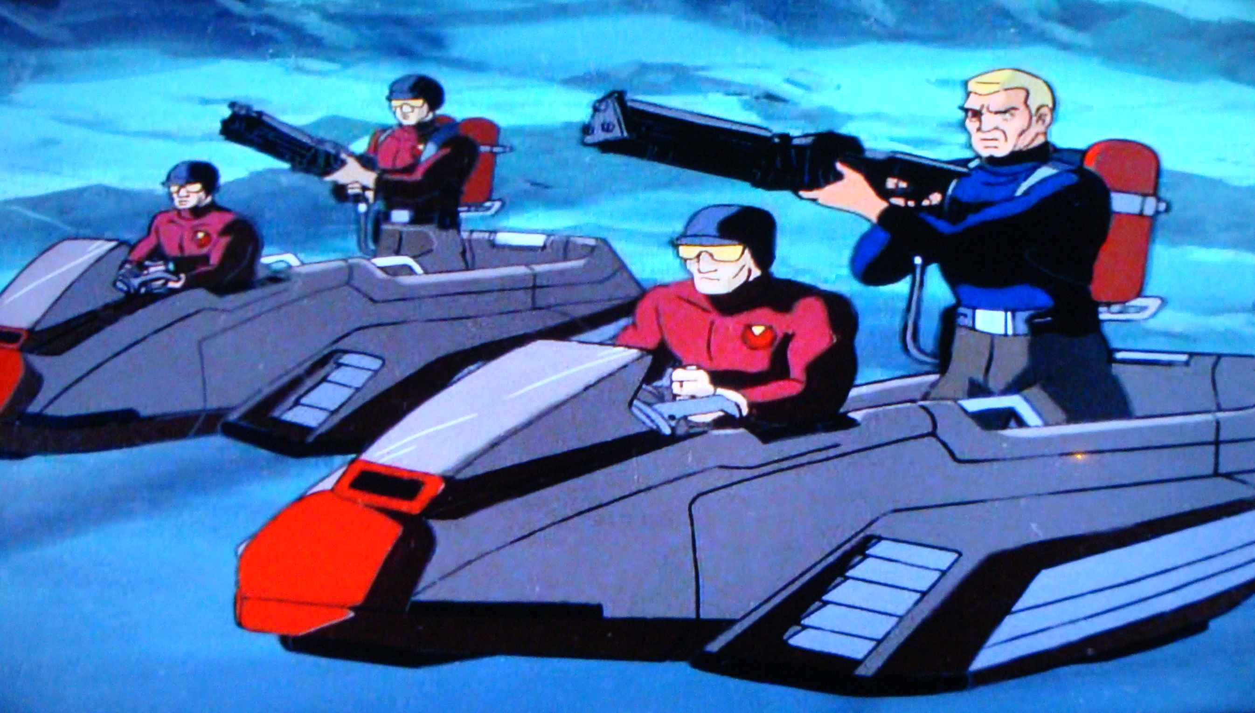
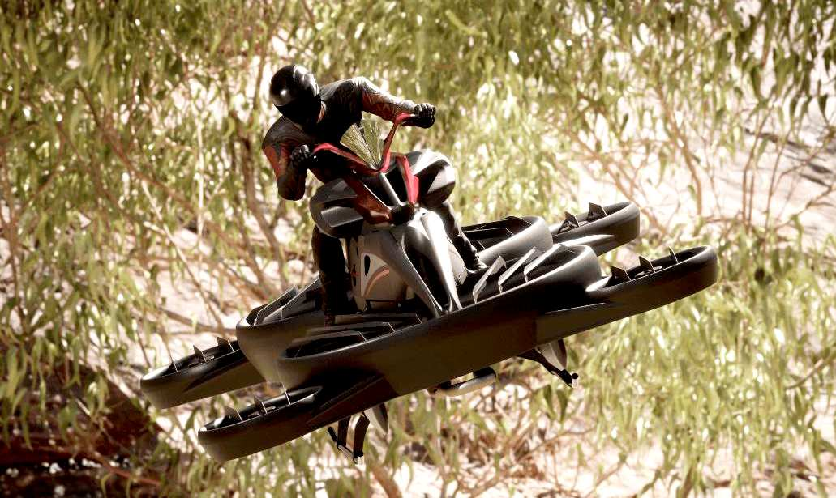
An interesting bit of gadgetry featured in this story is the real-world Xturismo hoverbike by ALI Technologies. I'd always regarded the various flying platforms featured in Jonny Quest as being a bit over the top. Now it seems that reality has caught up with Hanna Barbera's vision of personal air mobility.
At almost 67,000 words, The Storm is a bona fide Jonny Quest novel, over twice the length of my first Race Bannon Adventure. I'm aware that this is not your typical Jonny Quest tale, but I hope that readers will find it thought provoking and entertaining.

