Daughter of the Dragon is the third instalment in The Race Bannon Adventures. It takes place approximately one year after events depicted in The Synthetic Men and The Conspirators. This time around, we not only encounter Quest arch-nemesis Dr. Zin and his femme fatale daughters, but we delve into the backstory of the Zin Dynasty as seen from their point of view. We also venture into territory where few Jonny Quest stories have gone before, that of deliberately controversial subject matter.
The story opens with a play on the opening sequence from Jonny's Golden Quest, with a cameo by Race's doppelganger, Korchek, from the Classic JQ episode Double Danger. Avid Quest fans will likely recognize the Zin Twins, Anaya and Melana, from the Real Adventures episodes Bangalore Falcon and Night of the Zinja. Perhaps less familiar is Dr. Zin's other daughter, Jenny, featured in the Scooby Doo Mystery Incorporated episode Heart of Evil.


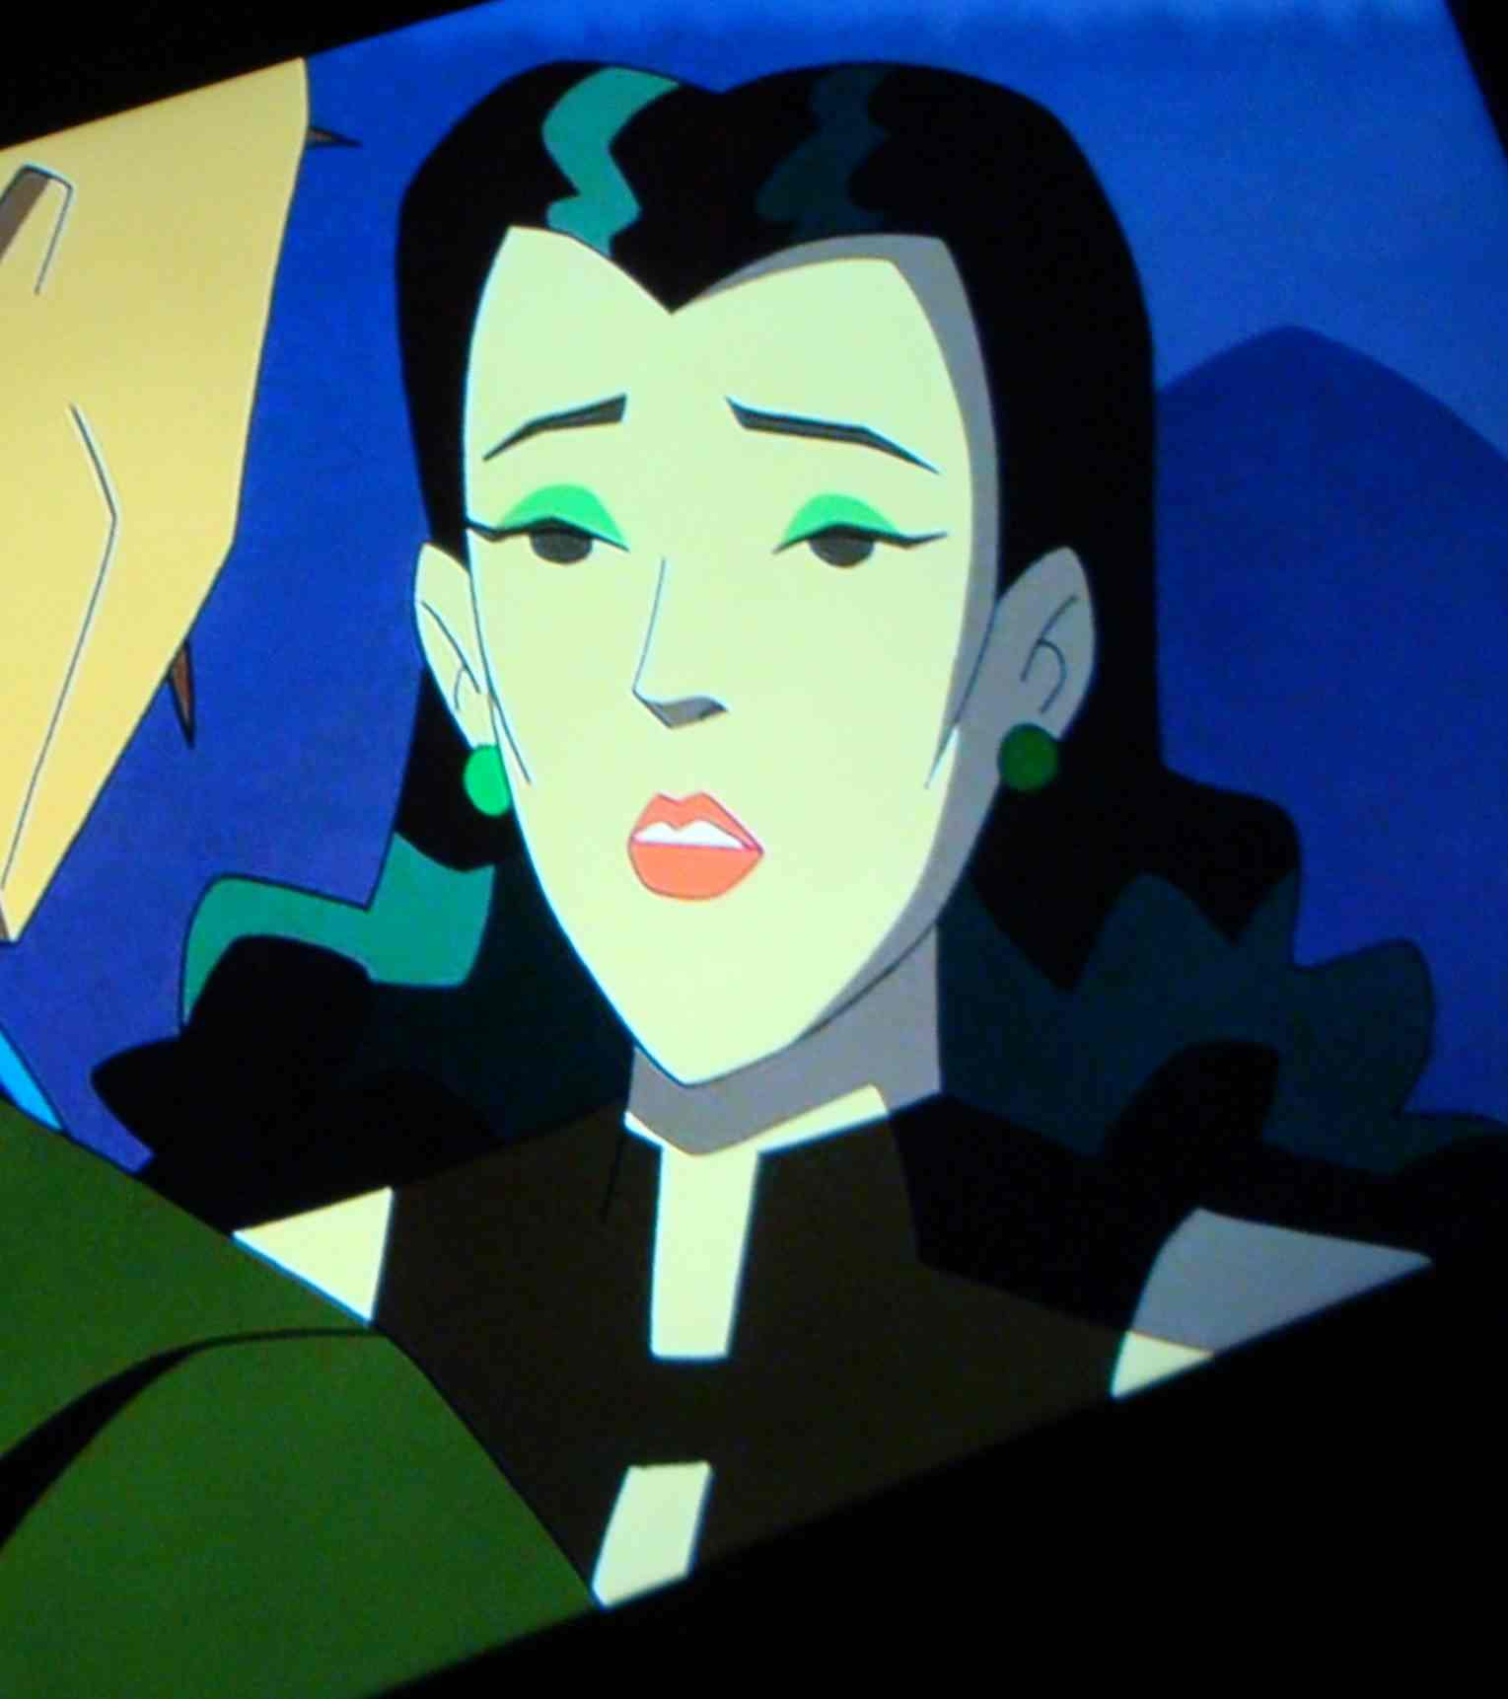

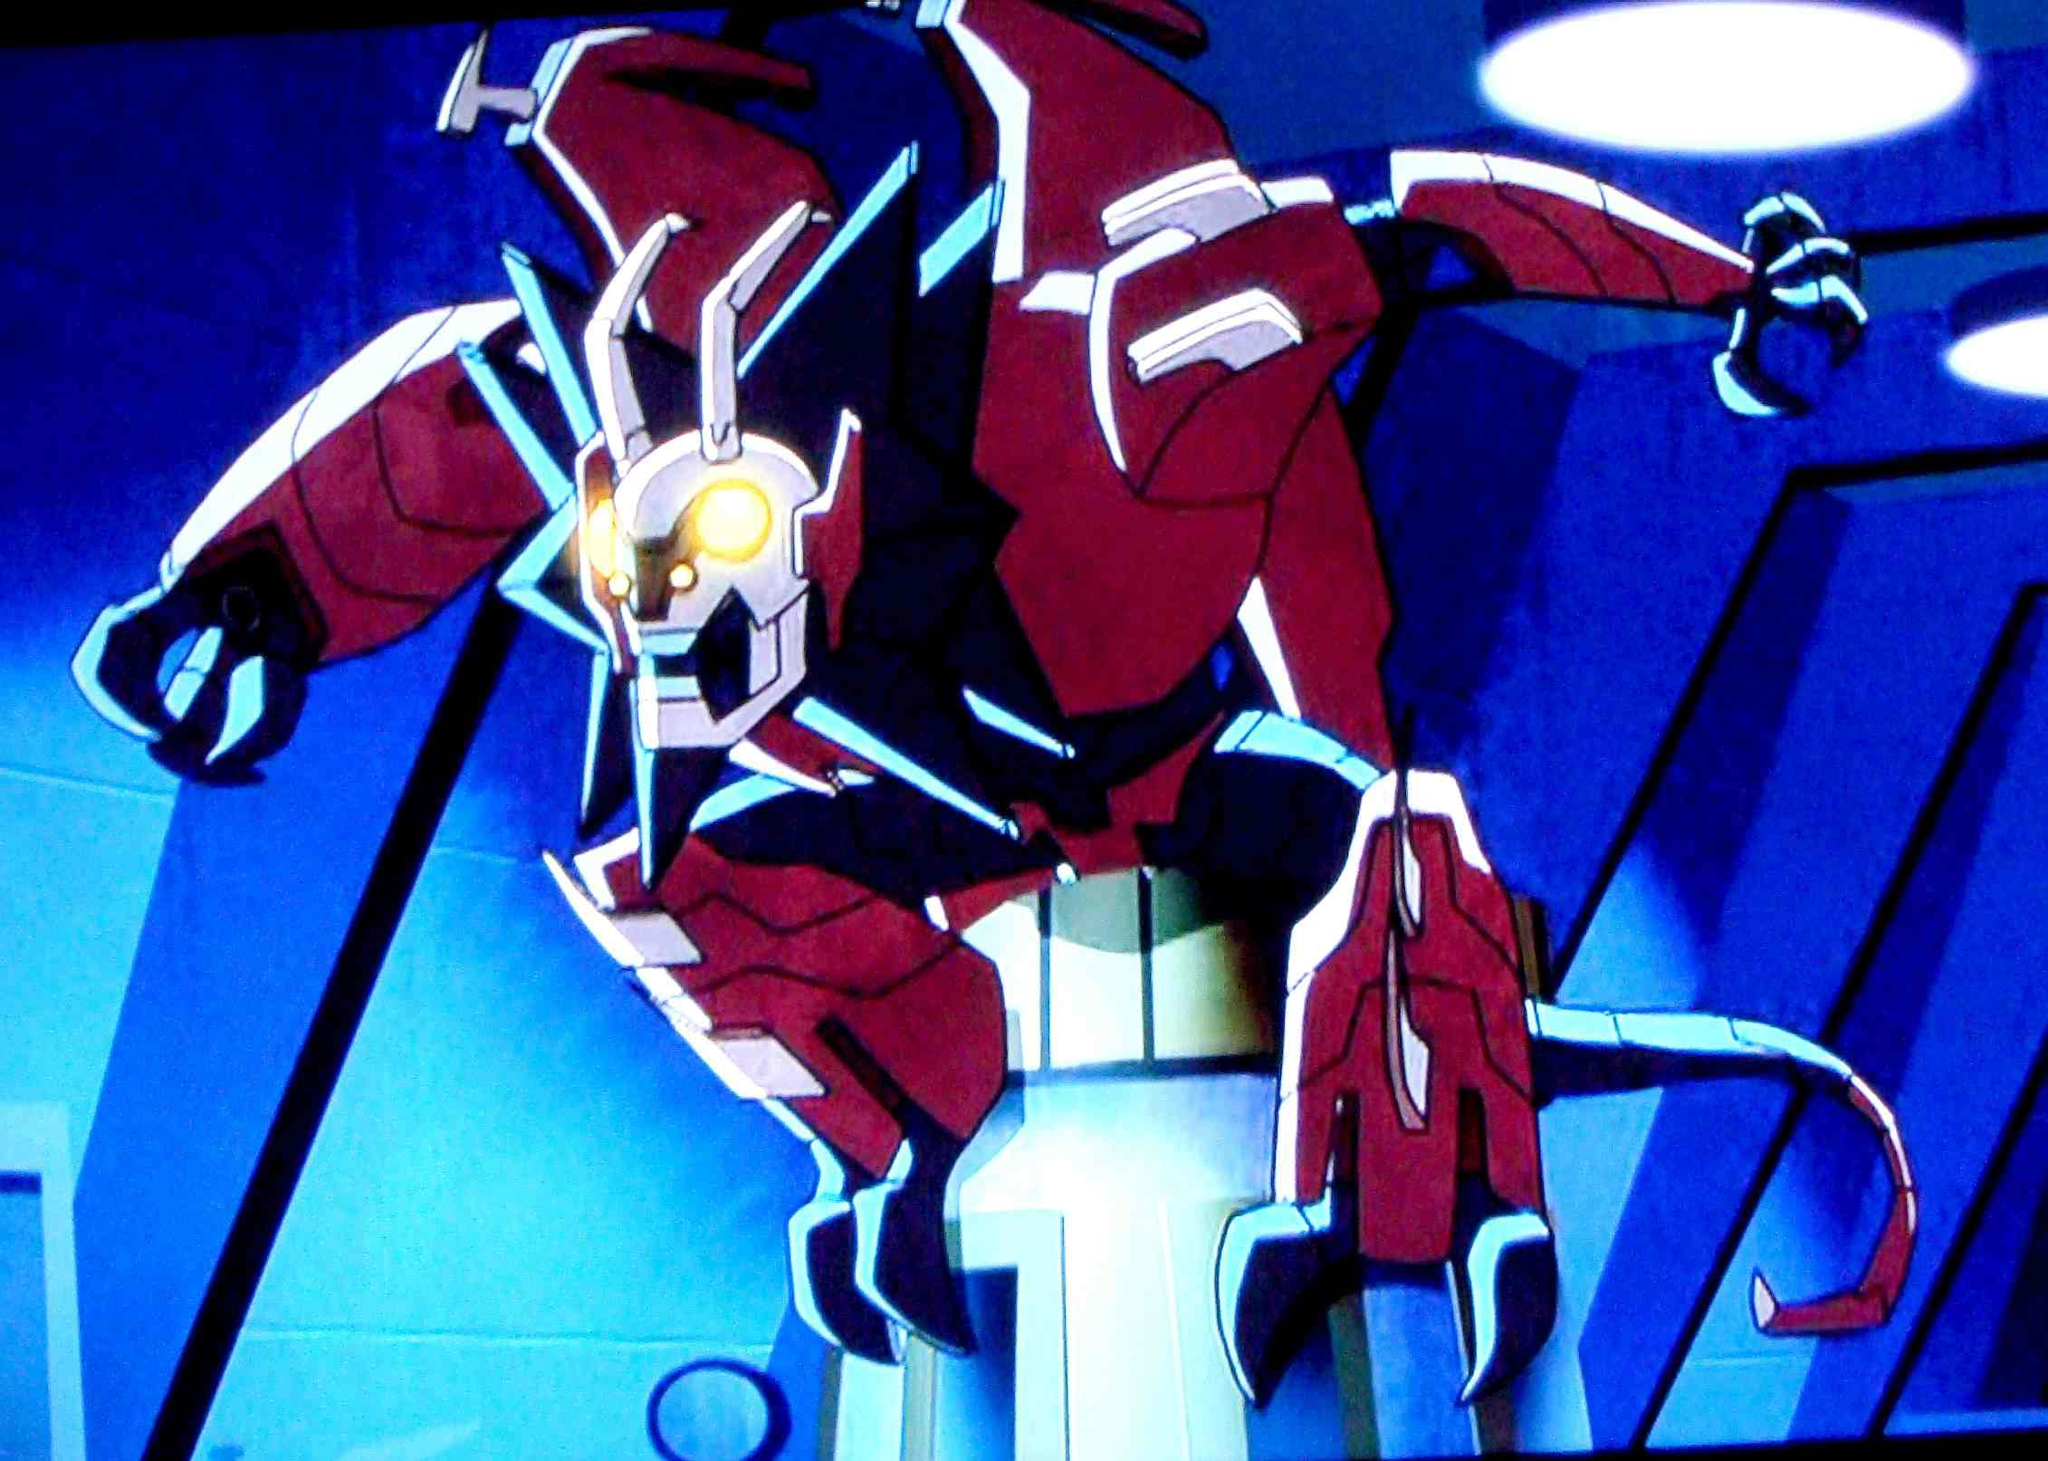
Jenny's Dragon Battlesuit and the Quest-X Power Source are also sourced from Heart of Evil.

Classic Jonny Quest was created in an era when Communist China was at its most virulent under the leadership of Mao Zedong. The US and China had battled in the Korean War and the Vietnam conflict was already unfolding. Jonny Quest reflected the Cold War mindset of that time. Like many of the "yellow peril" Oriental mastermind villains of the period, Dr. Zin was very much cast in the mold of Sax Rohmer's classic pulp nemesis, Dr. Fu Manchu. The title Daughter of the Dragon is from the 1931 movie of the same name, which in turn is loosely based on Rohmer's Daughter of Fu Manchu novel.
Fifty-five years later, today's People's Republic of China is the world's second largest consumer economy, on track to become the largest in the very near future. It is a respected nation with world-wide economic ties and growing political influence as it seeks to assume the role of a global superpower.
That said, the PRC remains a totalitarian state under the absolute rule of the Chinese Communist Party. Freedom of information is suppressed and human rights activists are subject to imprisonment, abuse, or execution. The CCP's global aim remains to establish a world order in which universal human rights are trumped by a doctrine of non-interference in other nations' internal affairs. I have attempted to portray the evolution of Dr. Zin and his daughters from their Classic JQ-era personas as reflecting the more nuanced threat posed by today's China.
There really are potential offshore oil and gas reserves under Western Canada's Queen Charlotte Sound. Descriptions of the SSCS Tianzhu and the Chinese sub-surface gas compression station are inspired by the real-world Åsgard compression station and the North Sea Giant, which was instrumental in its assembly. These are widely illustrated on the Internet and were featured in an episode of Mighty Ships (currently available on YouTube.)

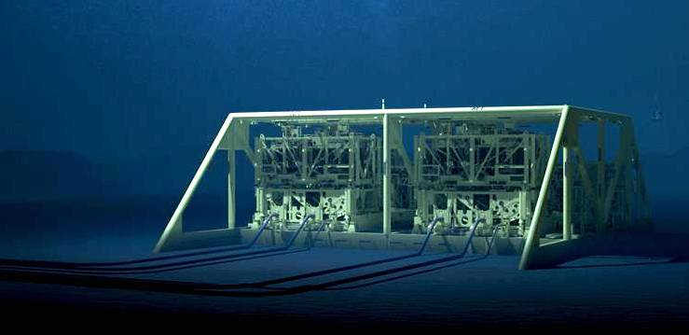

The concept of a fleet of oil and natural gas transport nuclear-powered supertankers was publicized in the March 1982 issue of Popular Mechanics.
The real-world question of involuntary human organ harvesting in China is very similar to how it's presented in Daughter of the Dragon. While this deeply troubling issue has never risen to become a source of widespread popular outrage, well-founded allegations continue to be raised by knowledgeable researchers some thirteen years after they first surfaced in Western nations.
While I don't expect all readers to agree with my portrayal of Canadian politics, it is based on twenty-three years experience as an American living in Canada, much of that time spent in Richmond, BC, a.k.a. North America's Most Asian City. Several real-world current events in Canadian affairs inspired my writing of Daughter of the Dragon. These include the Trans-Mountain Oil Pipeline controversy, the ousting of a former Justice Minister turned whistleblower over high-level government misconduct, and especially mainstream news reports exposing the extent of international, i.e. Chinese, criminal money laundering in the BC real estate market (estimated at $5.3 billion in 2018.)
While there's ample food for thought here, and hopefully an interesting modern take on some Classic JQ villains, at heart I've once again tried to create story material that recaptures the adventure, suspense, mystery, and chills of Classic Jonny Quest. Enjoy.

