In Corona, the fourth instalment of The Race Bannon Adventures, the world of Team Quest is upended by COVID-19, redefining relationships with old friends and foes. New adversaries this time out include Silky from the Classic JQ episode Attack of the Tree People and Col. Fong Hui, son of General Fong from The Quetong Missile Mystery. We also see cameos by Rachel Quest and Grandpa Doug Wildey from the Real Adventures episode Nuclear Netherworld. Finally, there's an important reference to the Real Adventures episode The Edge of Yesterday, which I won't elaborate here.
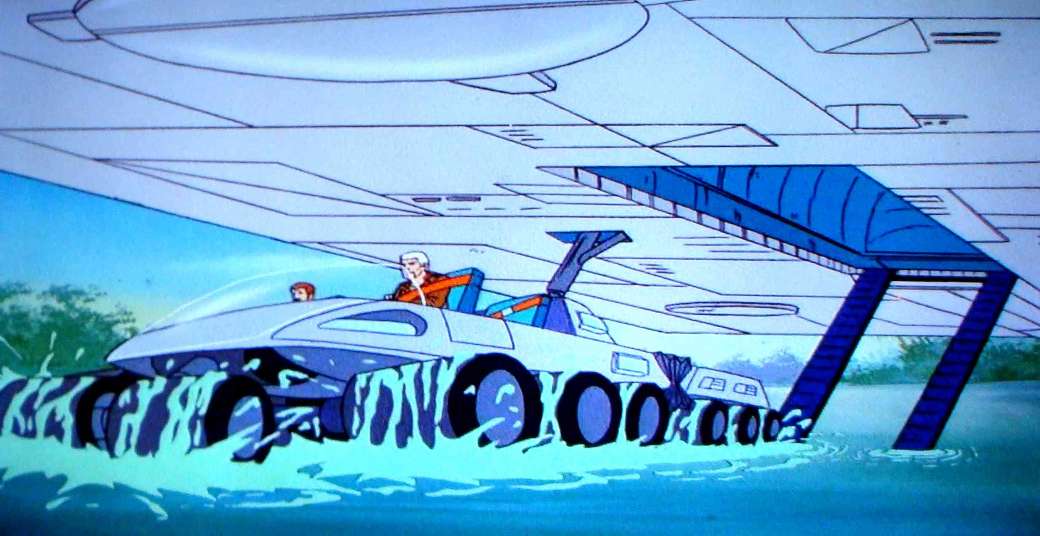
My favorite Jonny Quest outing remains the classic series, with its more adult storylines and menacing ambiance. Still, I also appreciate some of the more high-tech gadgetry and settings seen in later franchise entries. One of these innovations was Alex Toth's multi-wheeled Quest Land Rover from the Eighties Adventures. A few months ago, I came across a photo of the Rheinmetall MissionMaster in a Canadian military magazine. I thought this was the perfect real world incarnation of Toth's 8x8 concept. Thus the Quest TerrainMaster came about.


Corona was not the story I'd intended to write for my fourth JQ fanfic, however as 2020 progressed, it became apparent that any present-day storyline would have to incorporate the new normal of COVID-19. Each Race Bannon Adventures fanfic is written over a period of months. This story has been particularly challenging in that I've tried to hit a moving target, second guessing where events surrounding COVID might be several months after a section of narrative was written. As an example, when I was writing the portion about the more virulent Moro Strain of COVID emerging in the Amazon rainforest, the idea of a mutated COVID variant was pure fiction. Today, the emergence of more transmissible COVID variants, including the P.1 variant from Brazil, is threatening to become a serious challenge to efforts to contain the pandemic.
As Jonny Quest is a story about scientists, I've tried to present the science of COVID as accurately as possible coming from a layman's understanding. That said, information presented here should be regarded as for entertainment purposes only. For any healthcare decisions regarding COVID, refer to trusted sources.
Several key organizations presented here, including Red Cicada, the Global Health Organization, and the Wuhan Center for Zoonotic Microbiology, are fictional. The underlying subjects of wet markets, endangered wildlife trafficking, illicit global capital flow, and Chinese triad-based organized crime are very real.
The timeframe of the "Now" in which the middle chapters take place is a bit contrived. For story purposes, I wanted events to take place near the height of the pandemic, which in real life may still be yet to come. At the same time, I did not bring in events such as the 2020 Presidential election or the vaccine rollout, which are beyond the scope of the story. It remains to be seen whether the narrative I've laid out of the post-COVID world of a year from now will prove accurate.
Hopefully Corona will provide a good read while you're social distancing at home. Any feedback on The Race Bannon Adventures would be welcome and may be sent to RichardScarpitti@hotmail.com. Stay safe, be healthy, and follow Team Quest's example as seen below.
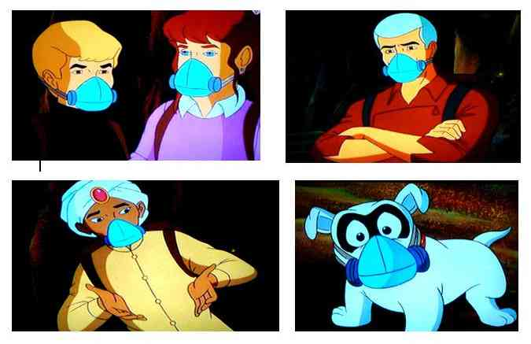
(Screencaps from Jonny Quest vs. the Cyber-Insects)

